**DATAIKU:**

Dataiku is an end-to-end data science and machine learning platform designed to help organizations build, deploy, and manage AI and analytics projects. It provides tools for data preparation, machine learning, data visualization, and collaboration, making it accessible to both technical and non-technical users

HOME PAGE:

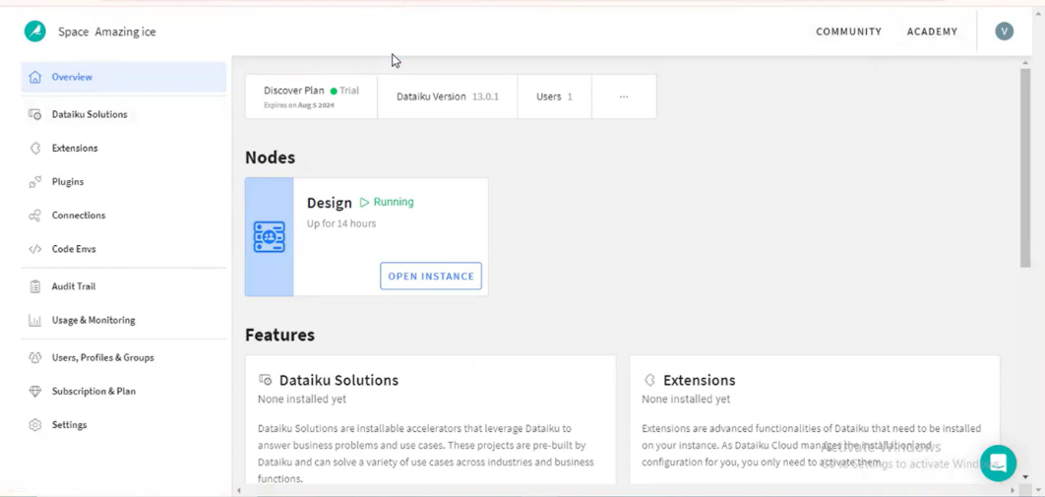

CREATE A NEW PROJECR:

STEP1: OPEN INSTANCE

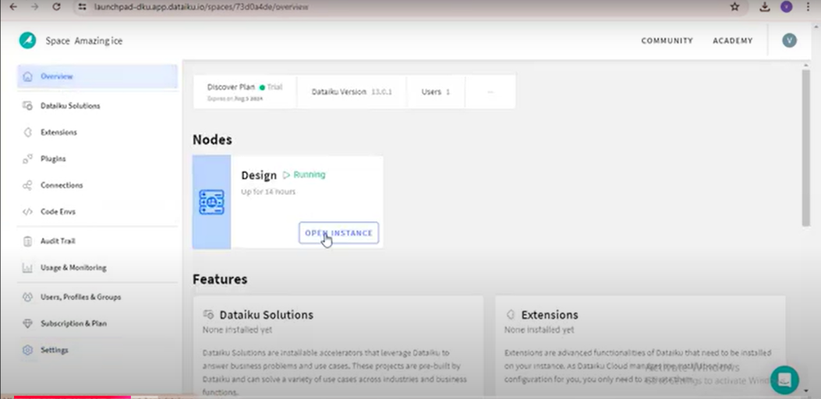

STEP2: OPEN BLANK PROJECRT

DESIGN NODE OPETIONS:

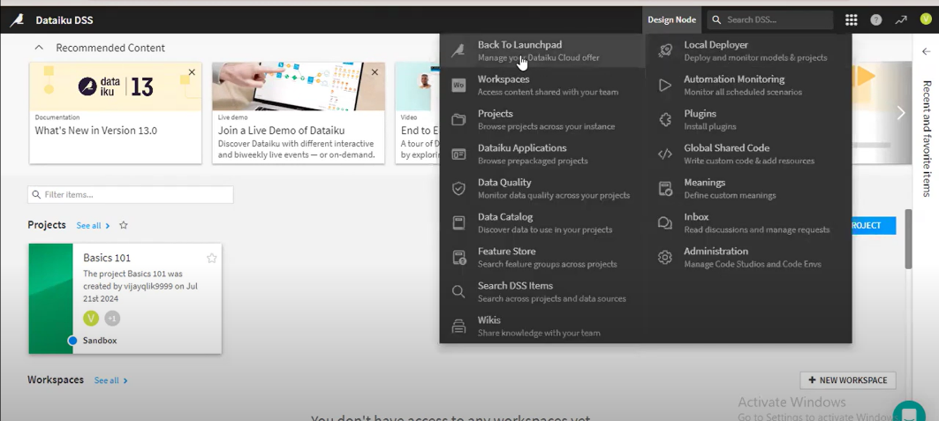

STEP2: CLICK ON BALNK PROJECT

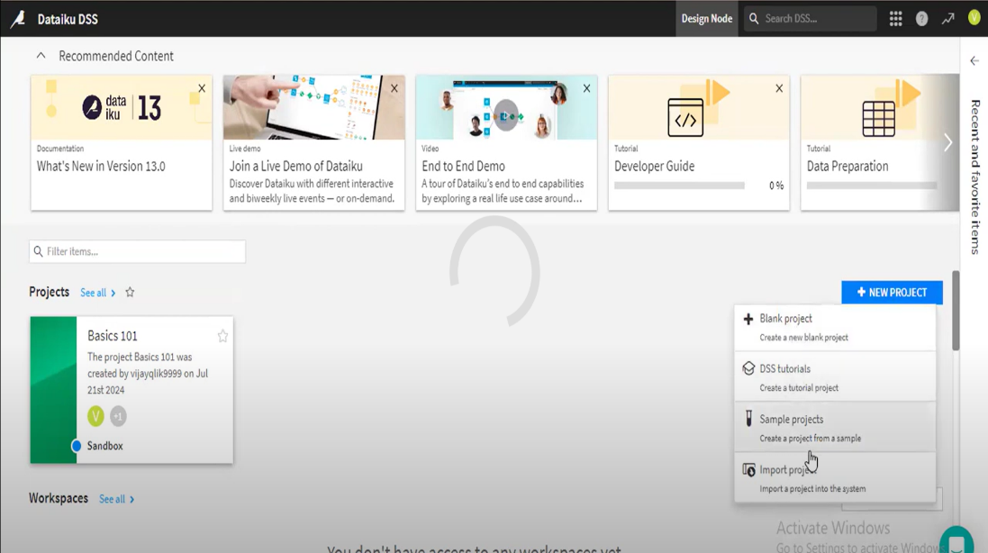

STEP3: CLICK ON NEW PROJECT AND CREATE

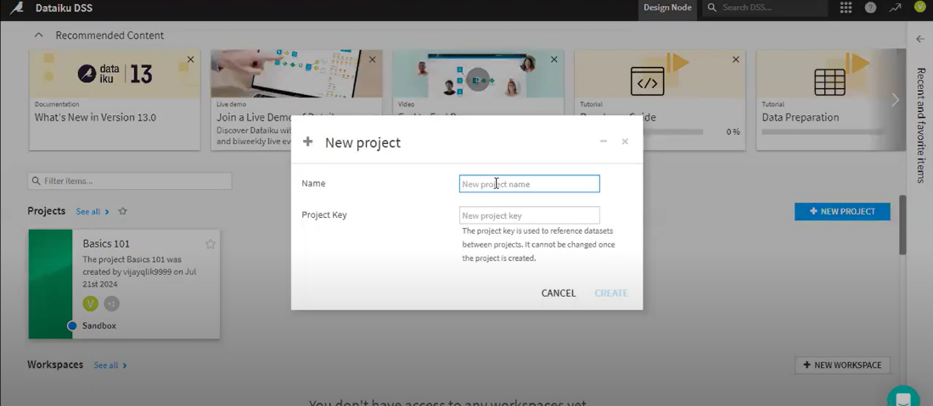

HERE THE VIEW OF YOUR PROJECT:

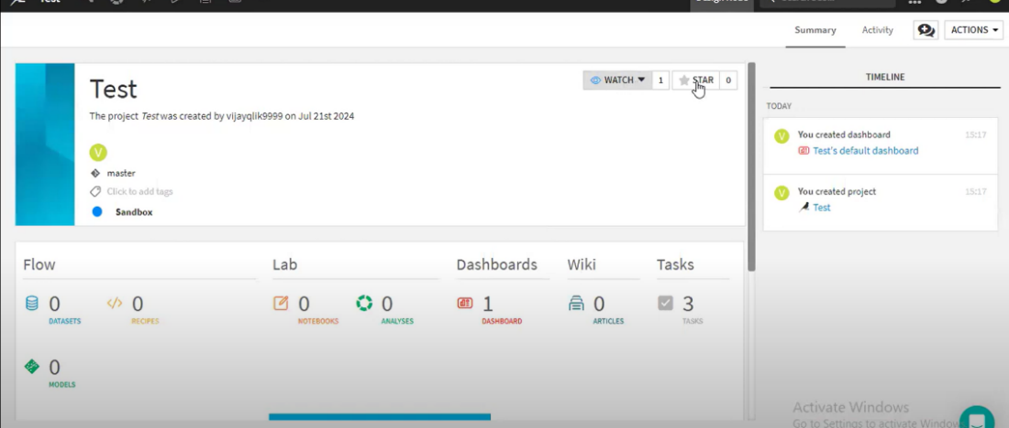

HERE YOU CAN ADD IMAGES TO YOUR PROJECT

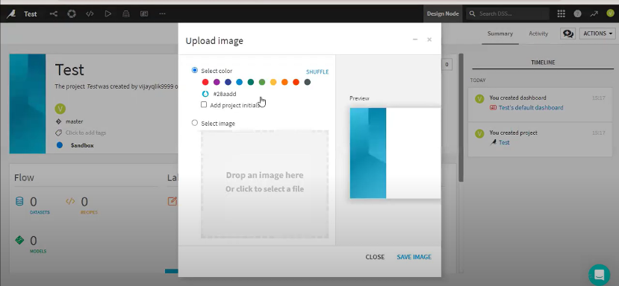

STEP4: GO TO FLOW AND IMPORT FILE

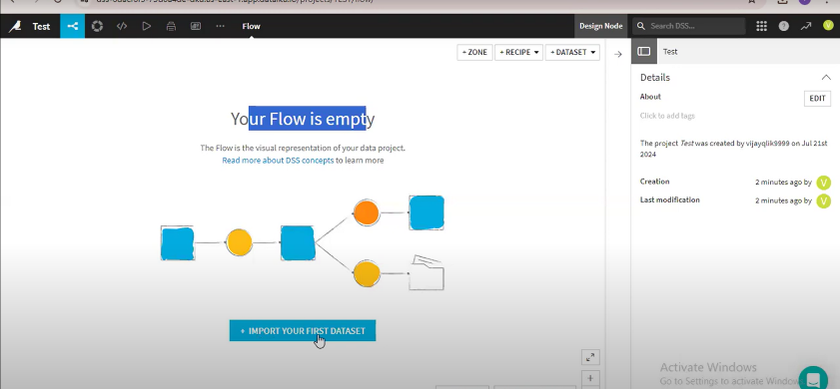

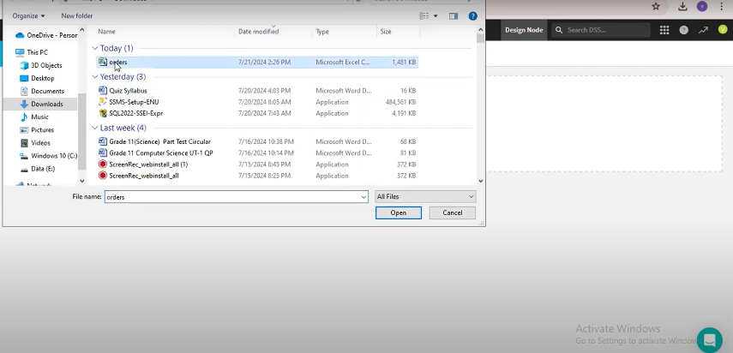

AND CLICK ON CREATE

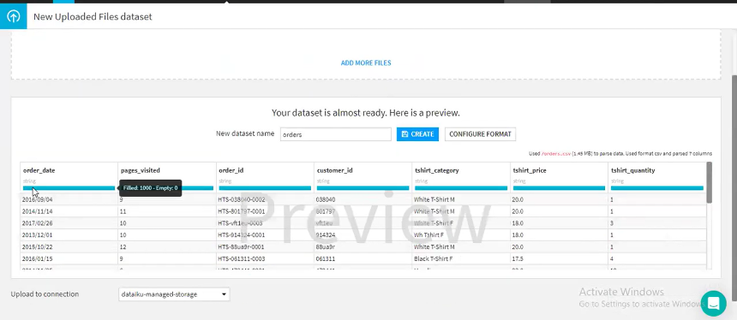

HERE YOU CAN CHANGE THE TBLE NAME AND CHANGE YOUR DATATYPE OF THE COLOUMN

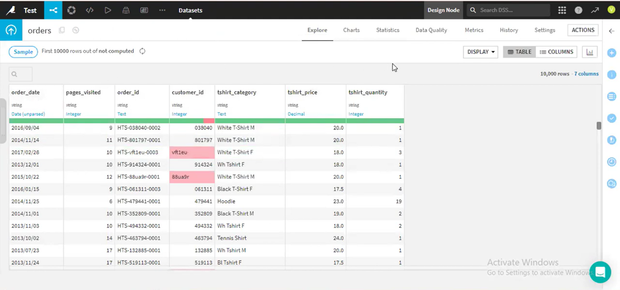

GO BACK TO FLOW

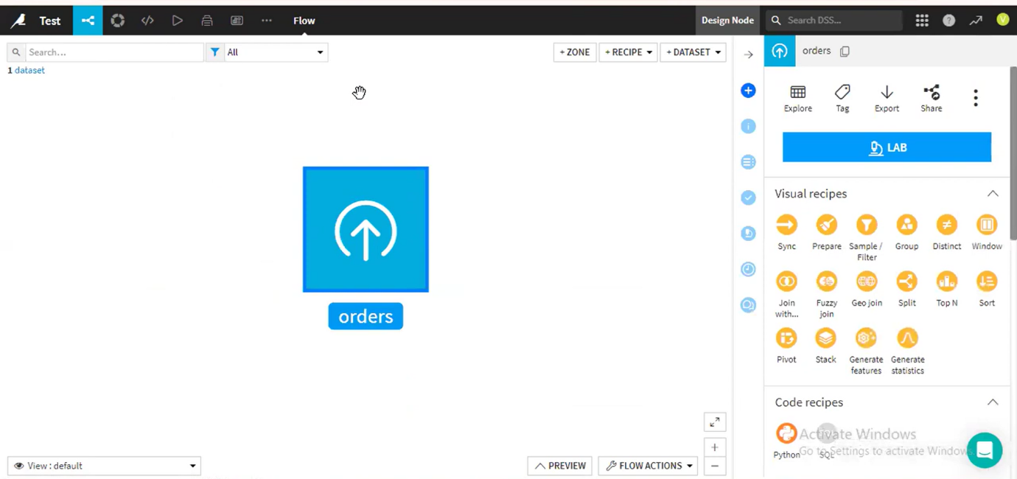

AND YOU CAN CREATE CHARTS HERE

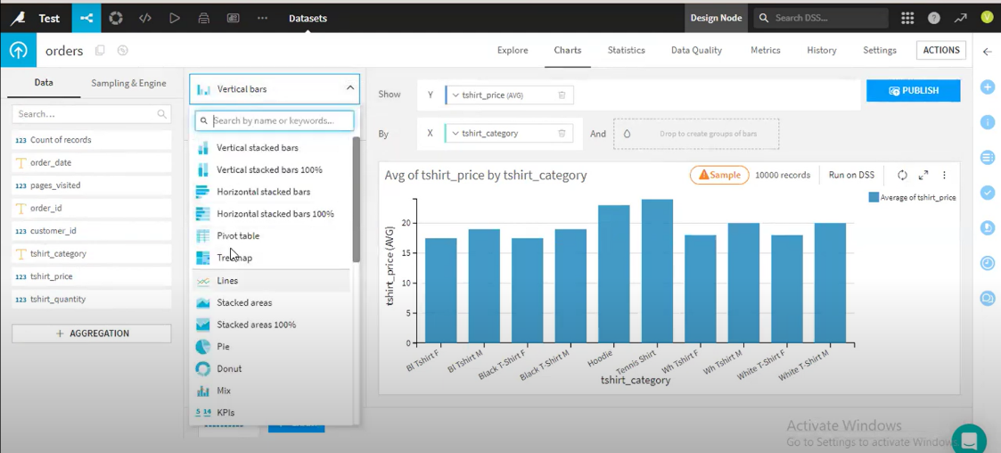

**RECIPIES:**

WHAT IS RECIPIES IN DATAIKU

In Dataiku, **recipes** are used to perform data transformations and processing tasks. They act upon datasets or folders and are represented by circles in the Dataiku Flow

**1.Data preparation:**

1. Data preparation is a vital step in any data analysis or machine learning project, transforming raw data into a clean and structured format

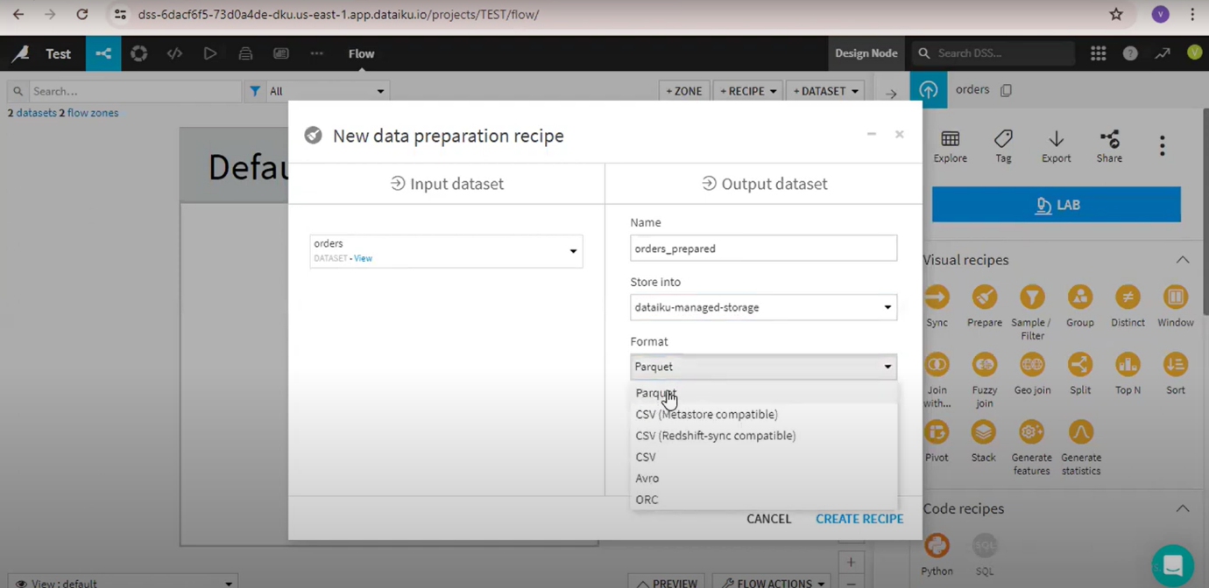

1. Select data format and create . then you get the following view

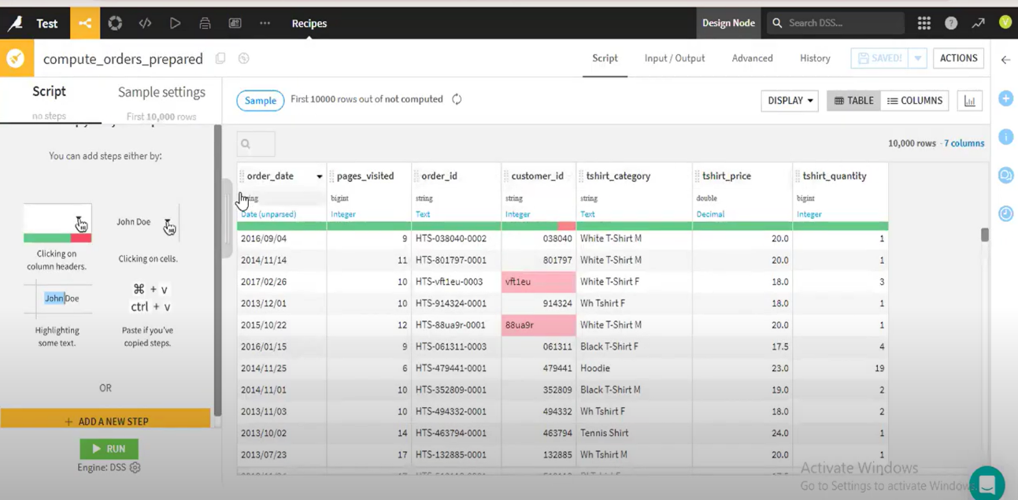

3.here you can filter the coloumns

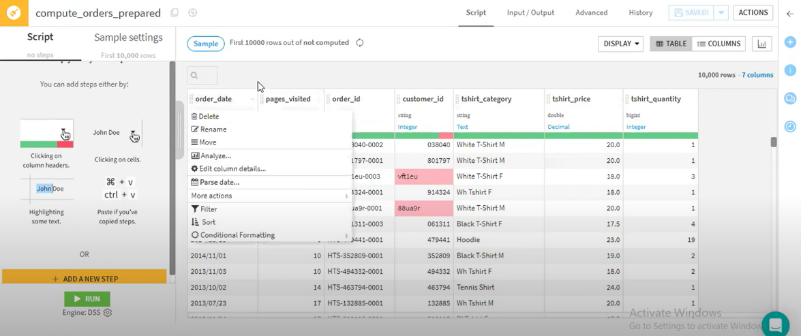

4.by using ADD A NEW STEP you can also perform operations like bello

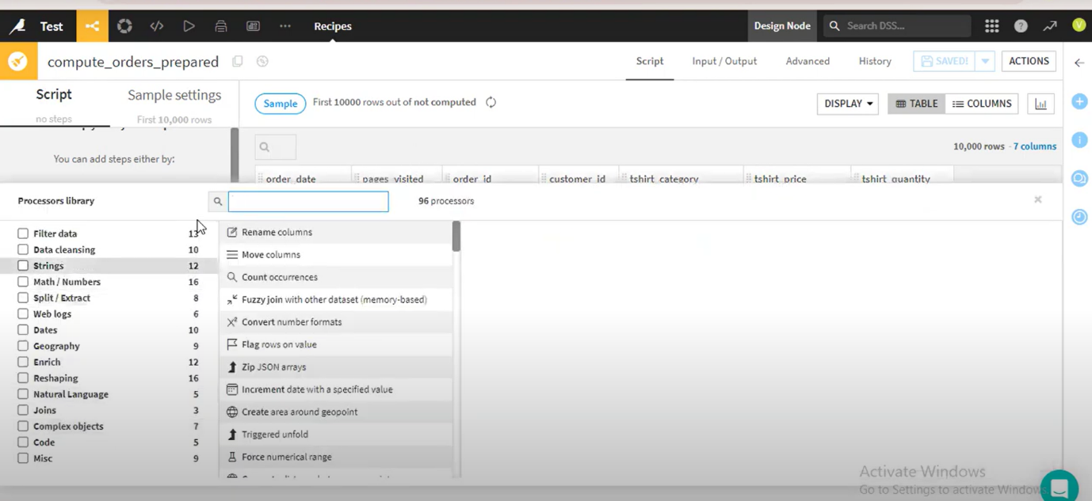

5.information about coloumns(here you can add , remove ect on coloumns)

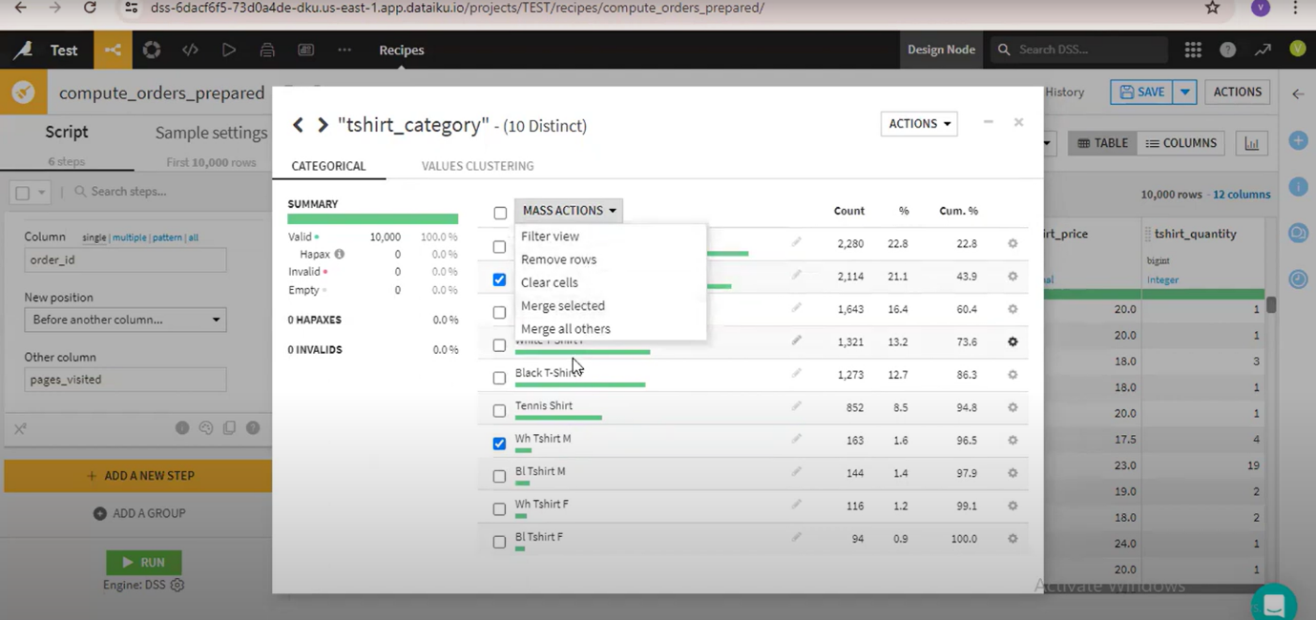

6. you can add formulas on your data

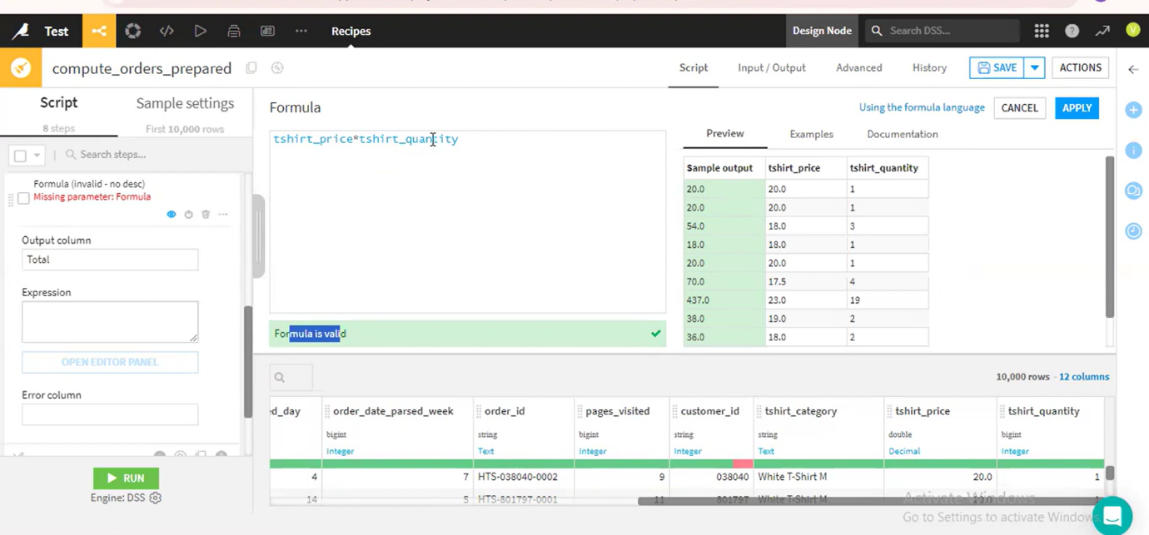

**2. GROUP:**

Used to perform aggregations and group by , such as calculating the sum, average, or count for groups of rows based on certain columns.

1. Fill the required coloumns

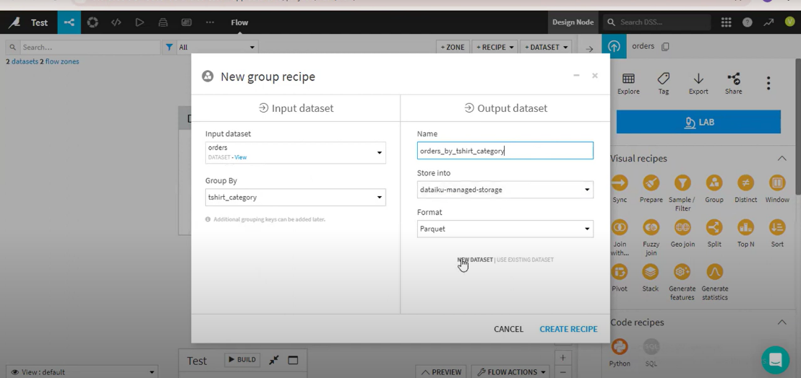

2.you get the following view

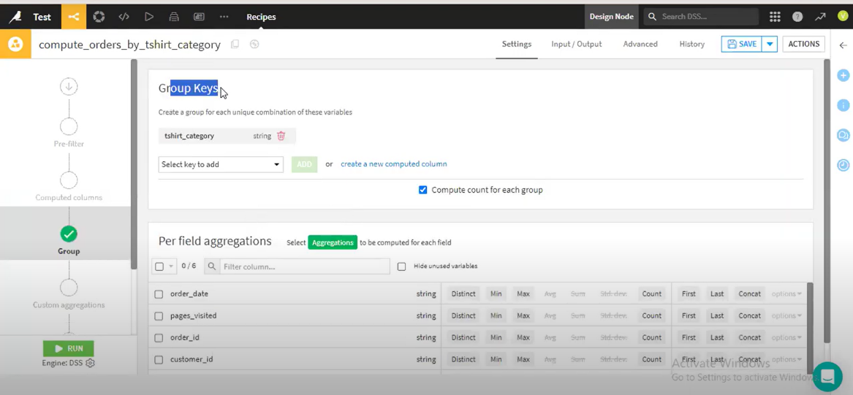

1. Select the aggregations to the columns

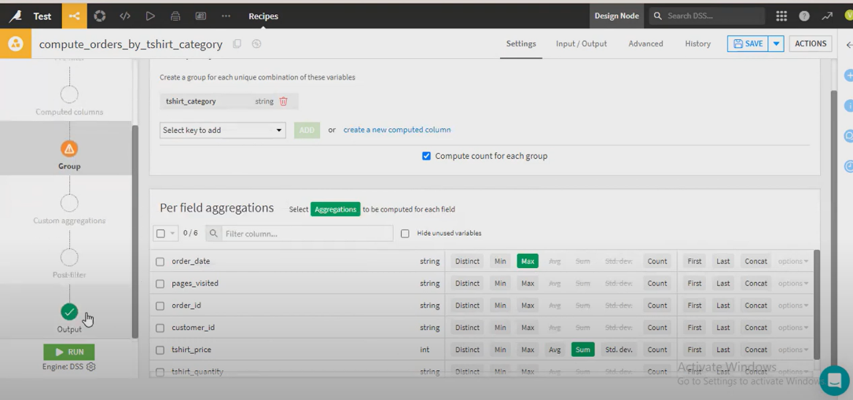

**3. join:**

**It can be used to join tables**

1. **Select two datasets and click on join opetion**

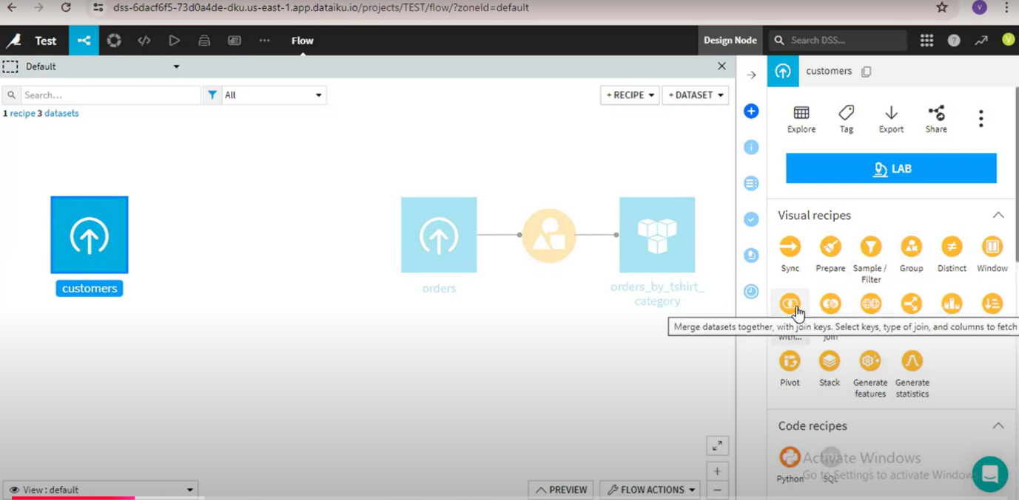

**2.fill the following fields and create**

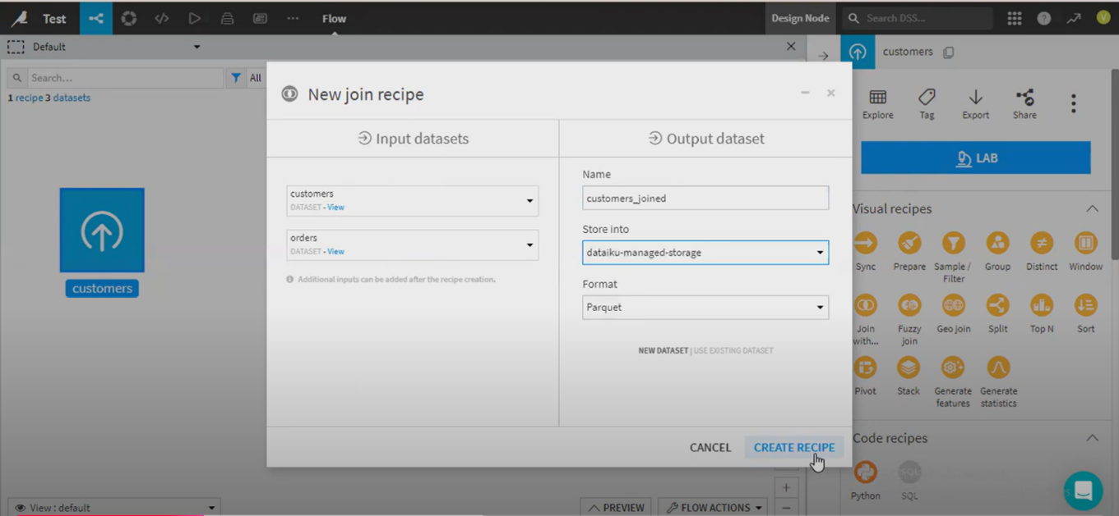

**3.View of the page**

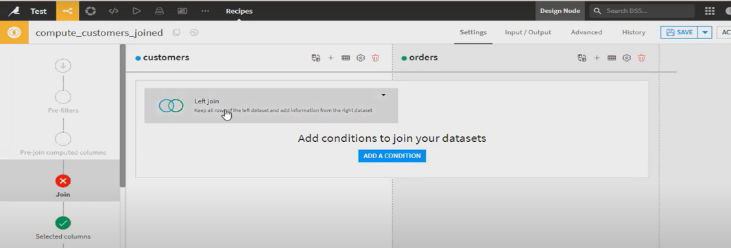

4.Select the join that you want to perform

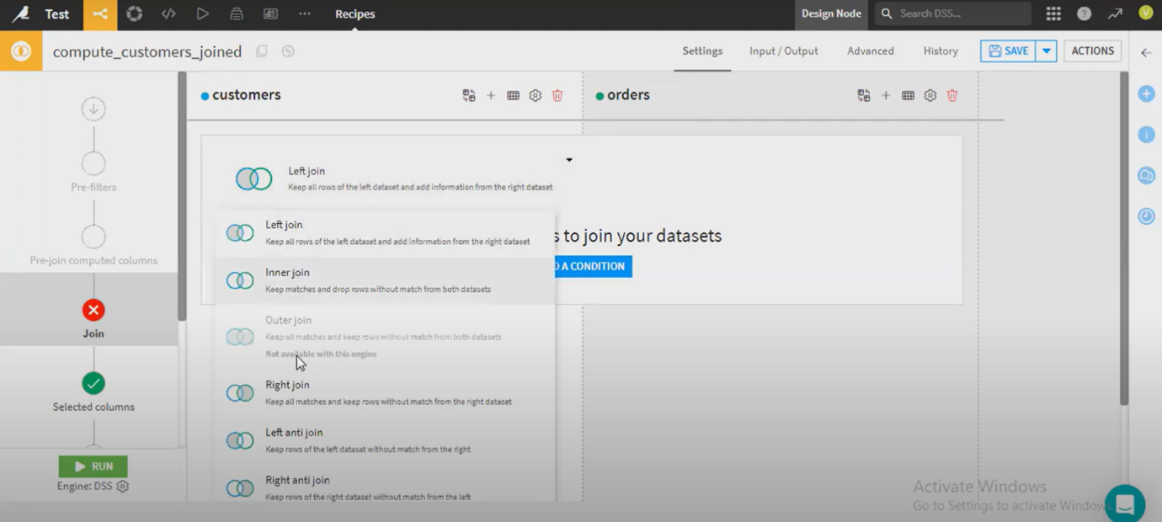

5.Give the join conditions

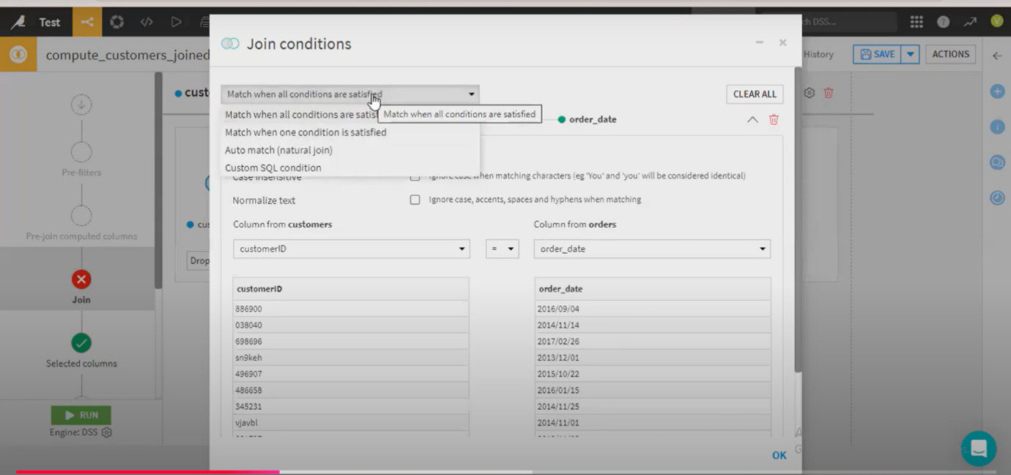

6. select the common in both tables columns 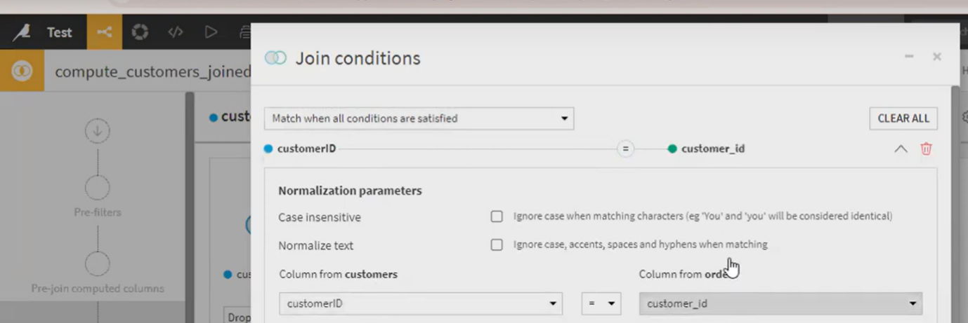

7. here you can remove the columns

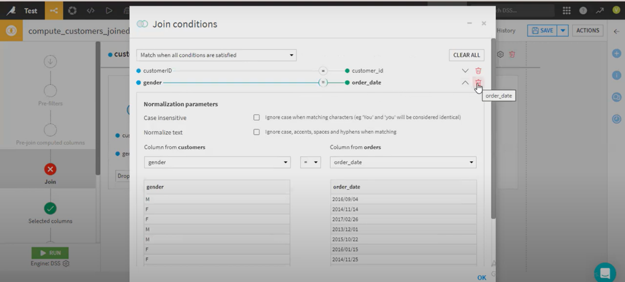

8. now select the columns

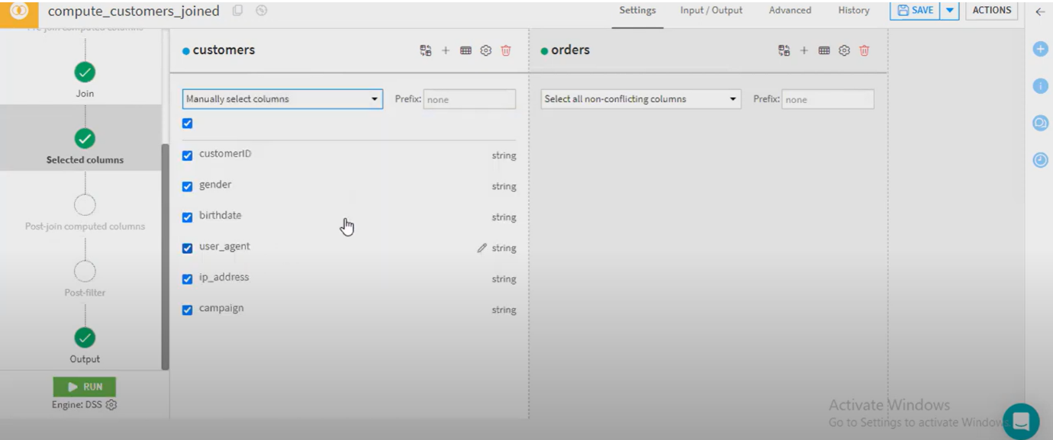

9. and check the output columns before run. Here you can also apply pre and post filters to the tables

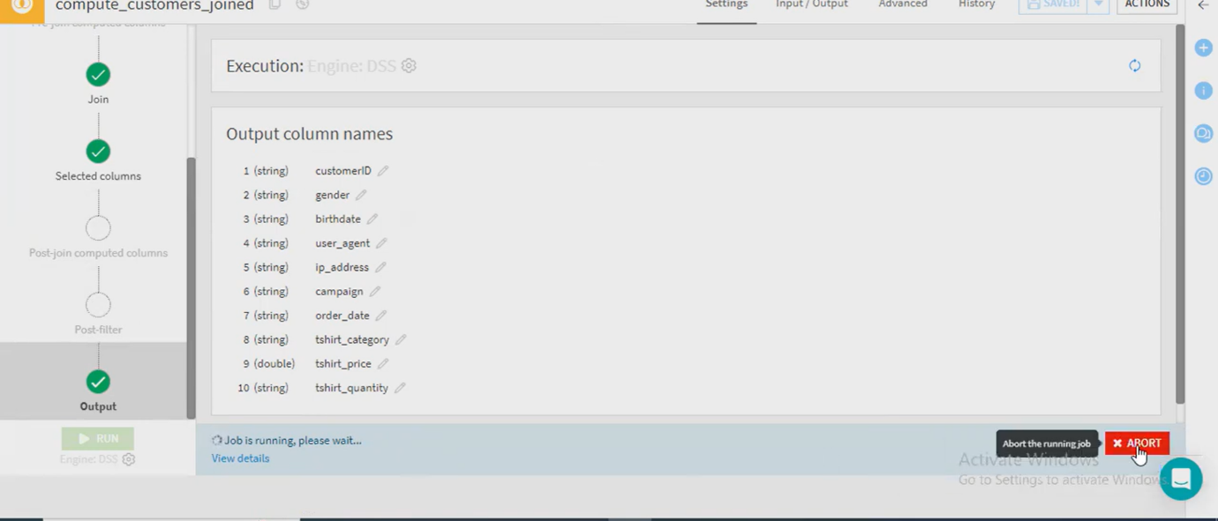

10. you can check output in the flow9

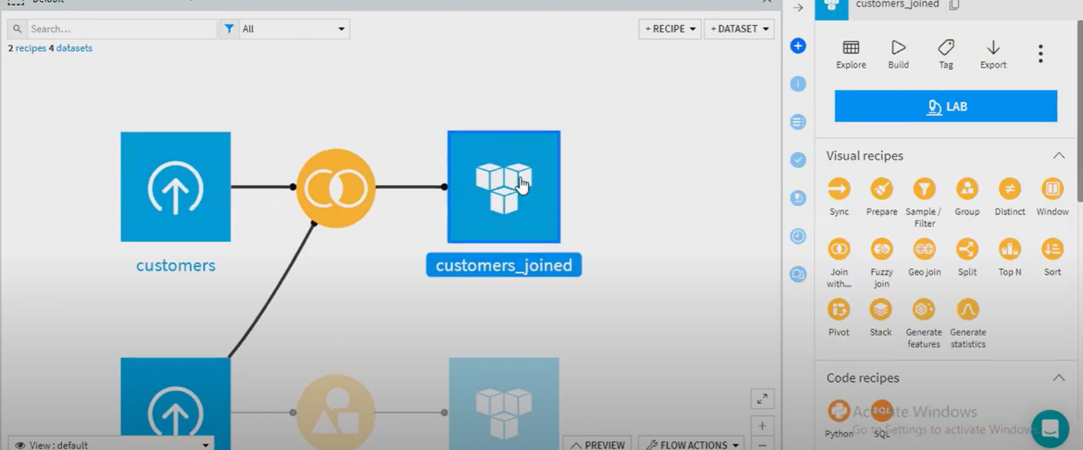

1. **Sync**

Sync recipe in Dataiku allows you to copy or duplicate an existing dataset within your Dataiku Flow. This can be useful for tasks like copying data from one storage backend to another or ensuring that datasets in different environments are kept in sync

1. Select sync recipe and the select the dataset and create

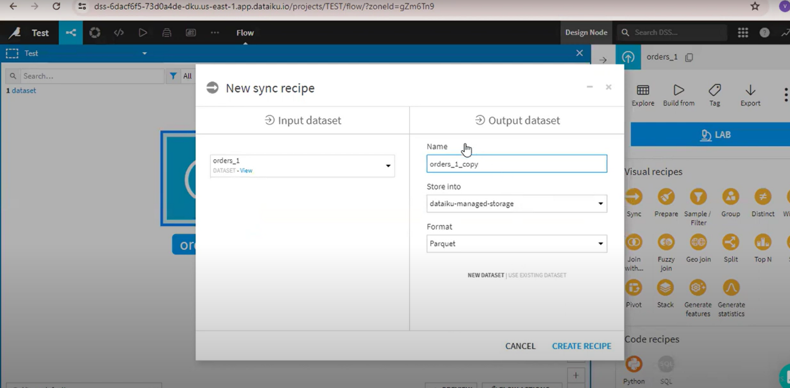

1. **In payment version you get two options more**
2. **Append ii. Merge**

**Select one of this and create a copy of your dataset**

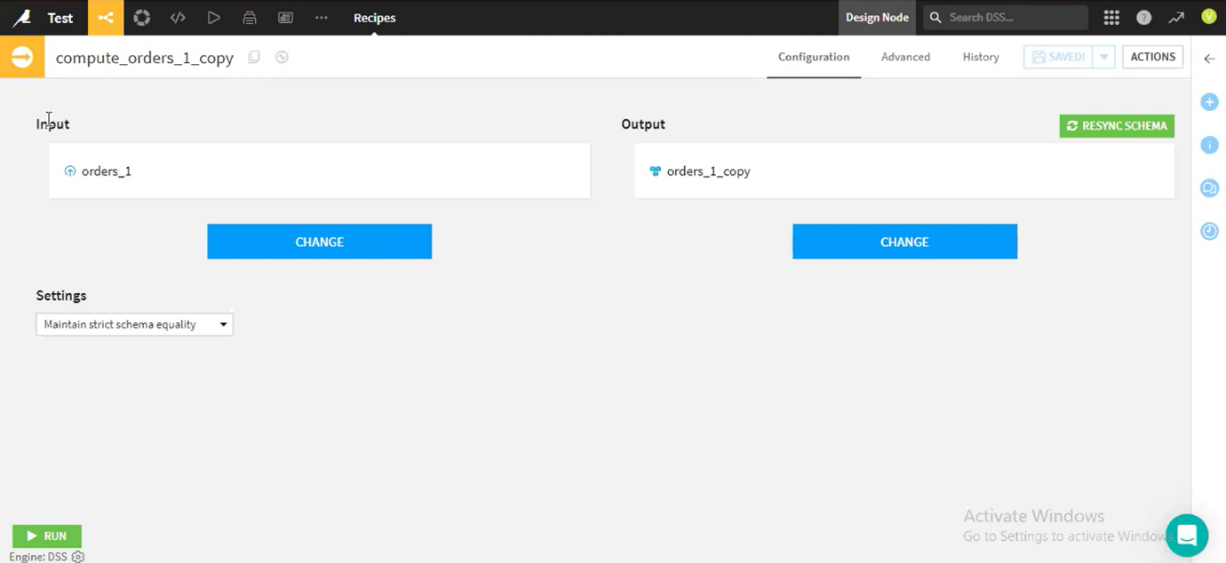

1. **Here you Can check the out dataset in the flow**

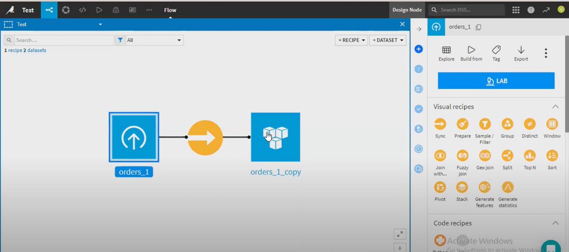

**4.sample/filter**

1.select the filter recipe and create

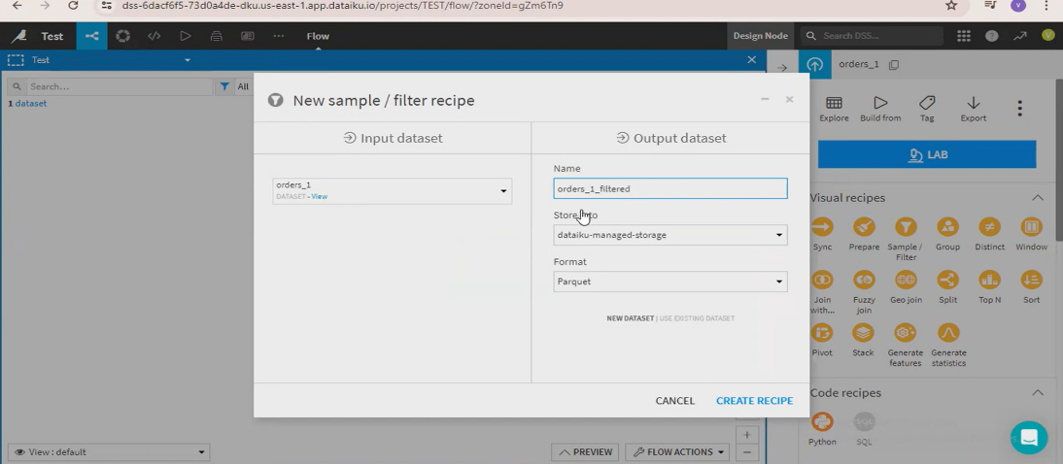

1. **Here it has three fields**
2. **Select the field which you want to filter**
3. **Select the operator(condition)**
4. **Select the value**
5. **Here we can add formulas**

**And you can select sample data or entire data and run**

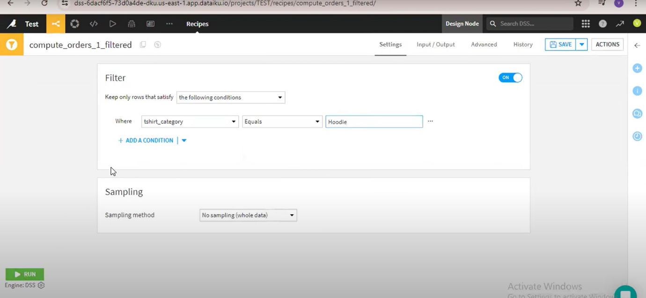

**You can see the output in flow**

